Thyroid autoantibodies AS early prediction MARKERS IN thyroid disease

Vibrant America, LLC

Thyroid DISEASE
Thyroid disease has been considered one of the most common autoimmune diseases since its two major clinical diseases, hypothyroidism (often caused by Hashimoto’s disease) and hyperthyroidism (mainly by Grave’s disease) are caused by auto antibodies.¹ Thyroid disease is mainly associated with decreased quality of life, Grave’s ophthalmopathy and dermopathy, osteoporosis, cardiovascular diseases and inherent risks in pregnant women and neonates.²⁻³ Rarely, it can be life threatening causing myxedema coma or thyroid storm.⁴ A set of hormones and autoantibodies are associated with thyroid disease such as thyroid-stimulating hormone (TSH), thyroxine (T4), triiodothyronine (T3), reverse T3, anti-TPO, anti- Tg etc., but TSH and FT4 are considered the cornerstone markers when determining thyroid disease. ⁵ Thyroid disease is not one particular disorder but a spectrum of diseases with both asymptomatic and symptomatic disease stages. The disease stage is often determined by evaluating the symptoms and serum levels of thyroid hormones, specially TSH and Free T4(FT4), since FT4 gives the unbound active amount of T4 in blood rather than the total T4 including inactive protein-bound hormone. This spectrum of disease can be ranged starting from asymptomatic subclinical hypothyroidism (high TSH, FT4 in-range) and sub clinical hyperthyroidism (low TSH, FT4 in-range) to overt hypothyroidism (low TSH and high FT4) and overt hyperthyroidism (high TSH and low FT4) which may or may not have symptoms. The end of the spectrum is the symptomatic thyroid disease which is associated with both abnormalities in serum levels of TSH and FT4 and physical symptoms.⁶
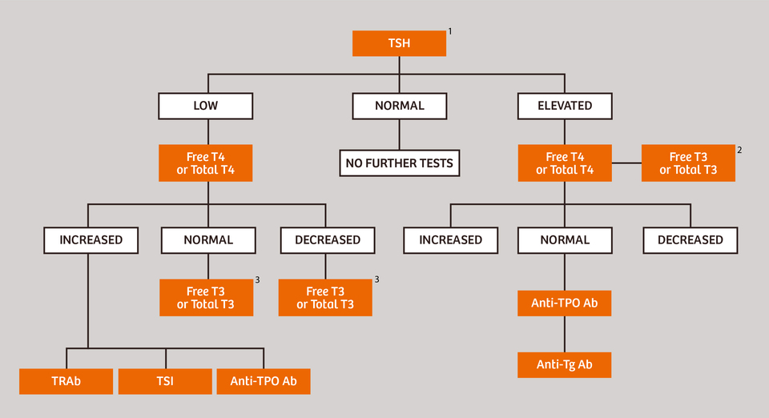

Figure 1. Traditional Patient Assessment Stratification for Thyroid Dysfunction⁷

Auto antibodies as early prediction markers in thyroid disease
Even though thyroid disease is not life threatening, early detection and treatment of thyroid disease would prevent long-term morbidity and mortality from cancer, osteoporosis, cardiovascular diseases and specially reduce the risks of miscarriages in asymptomatic patients if identified early and treated appropriately. Hutfless et al showed that thyroid autoantibodies, mainly anti-thyroperoxidase (TPO), anti-thyroglobulin (Tg) are present up to 7 years before clinical diagnosis in Graves’s and Hashimoto disease patients.⁸ Hence, measuring anti-TPO and anti-Tg as a first-tier screening test in conjunction with TSH and FT4 would clearly serve as a disease predictive as well as confirmatory markers, thus be helpful for close monitoring, early treatments and supplements to prevent long term morbidity.
Our STUDY: Early occurance of thyroid autoantibodies, anti-tpo and anti-tg
Method
The eligible study population comprised of subjects who were addressed to Vibrant America Clinical Laboratory between May 2016 to April 2018 for minimum four thyroid disease markers (Free T4 hormone (FT4), TSH, anti-TPO, anti-Tg).
- Anti-TPO and anti-Tg auto antibodies as early markers
Anti TPO, anti Tg TSH and FT4 were evaluated in Group A1 ( anti-TPO was positive at the first visit and consistent but TSH and FT4 were in range for at least the first visit) and group A2 (anti-Tg was positive at the first visit and consistent but TSH and FT4 were in range for at least the first visit) subjects.
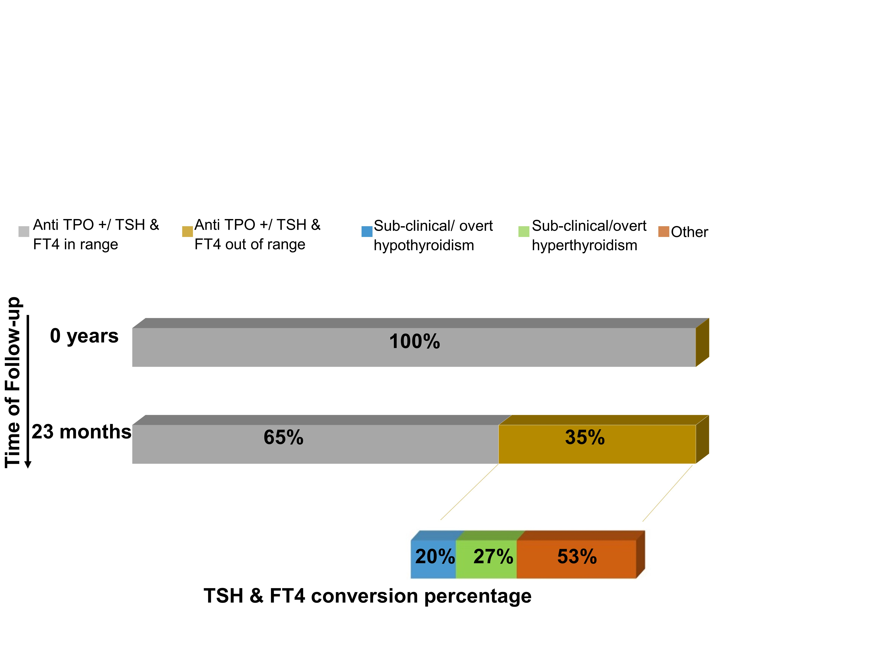
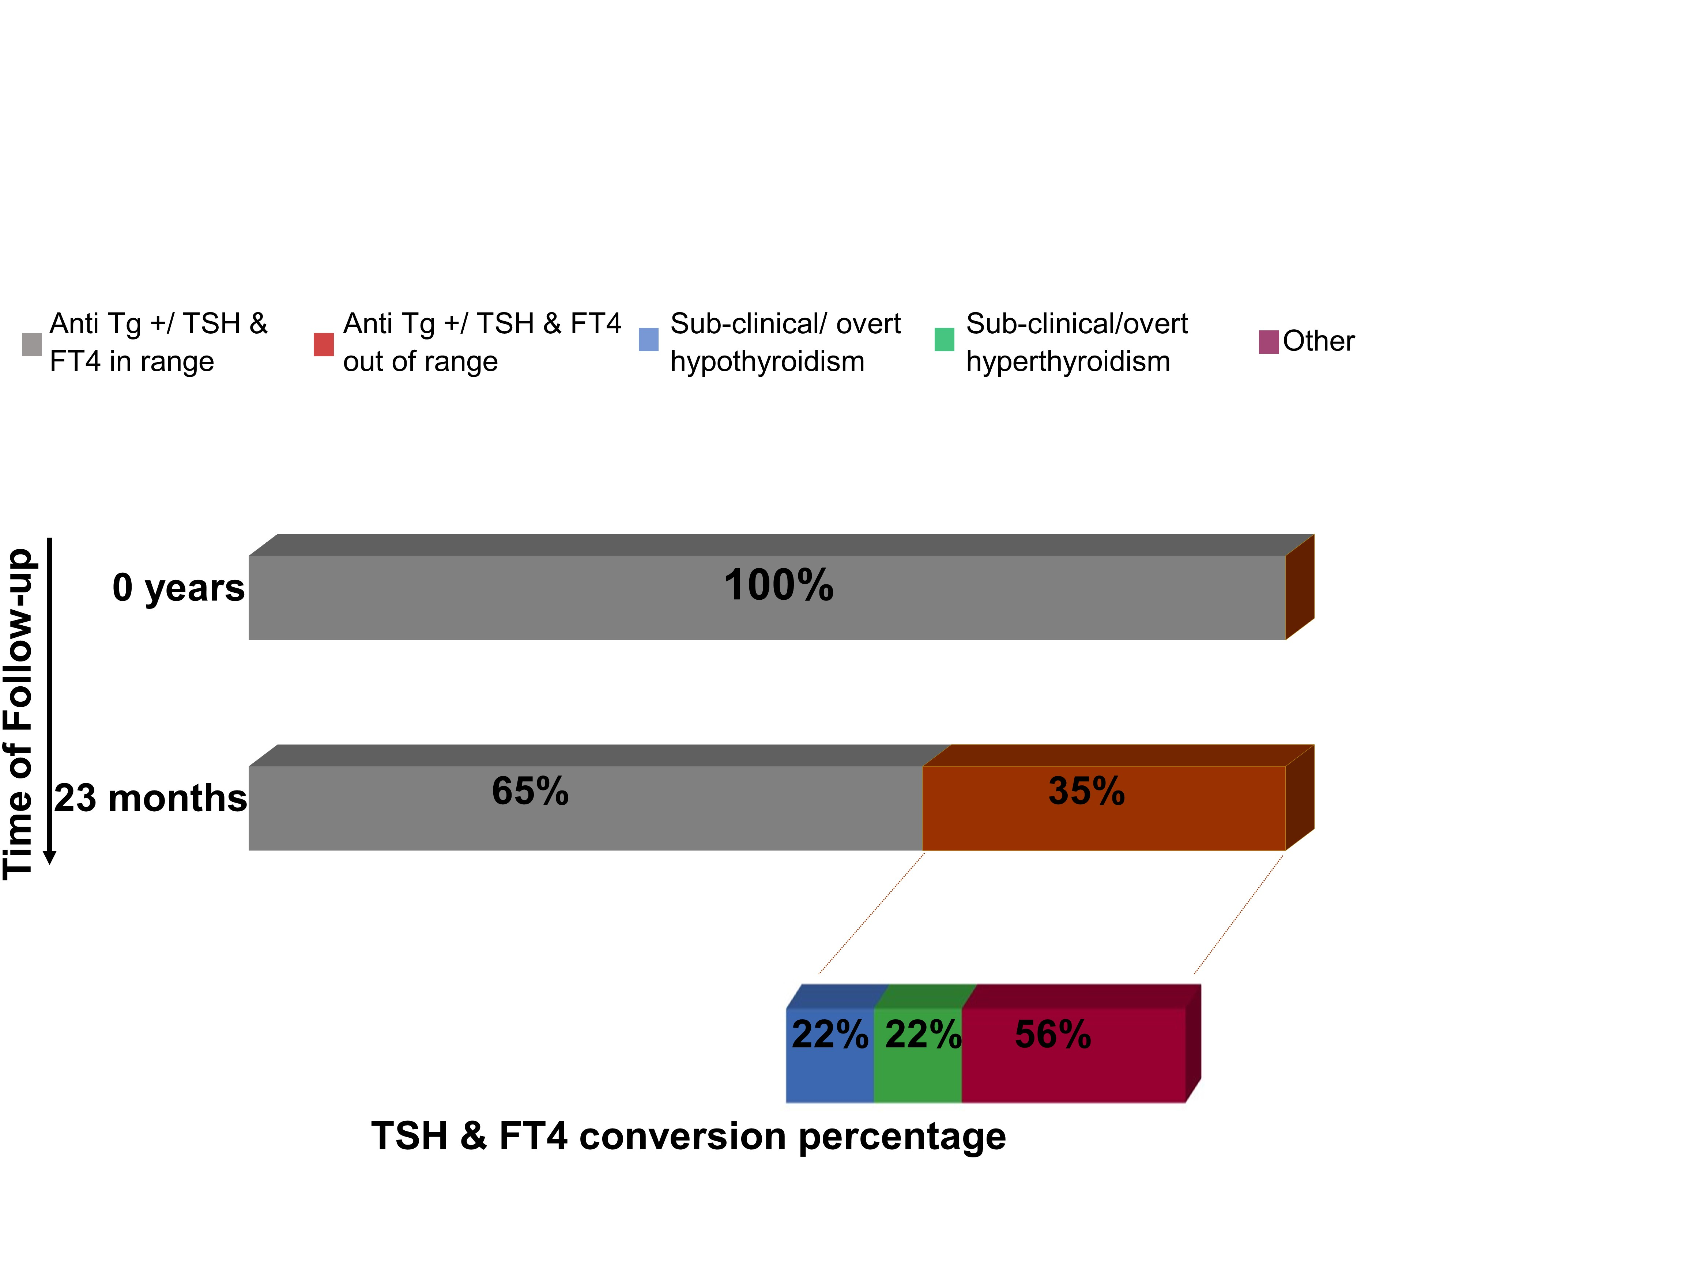
A
B

Figure 1. Conversion of group A1(A) and group A2(B) subjects into different thyroid disease sub categories for over two years of follow up testing for thyroid disease hormones.

In group A1, 151 (35%) subjects who had anti-TPO autoantibodies have developed into an atypical TSH or FT4 condition, where approximately 71 (47%) of them converted to sub-clinical or overt hypothyroid or hyperthyroid condition, during the 23 months. Similarly, in group A2, 118 (35%) had anti-Tg prior the onset of atypical TSH or FT4, where approximately 52 (44%) of them converted to sub-clinical or overt hypothyroid or hyperthyroid condition, during the 23 months. The remaining 65% subjects who had TSH and FT4 in range in both group A1 and group A2 may have the potential to develop into asymptomatic condition and later symptomatic thyroid disease. This hypothesis is based on a study that Hutfless et al. showed on the preexistence of anti-TPO and anti-Tg autoantibodies 7 years prior to the concise diagnosis of Hashimoto’s (66% and 57% for anti TPO and anti Tg respectively) and Graves’ disease (57% and 47% for anti- TPO and anti-Tg respectively) for 174 patients.⁸
- Prevalence of Anti-TPO and anti-Tg antibodies
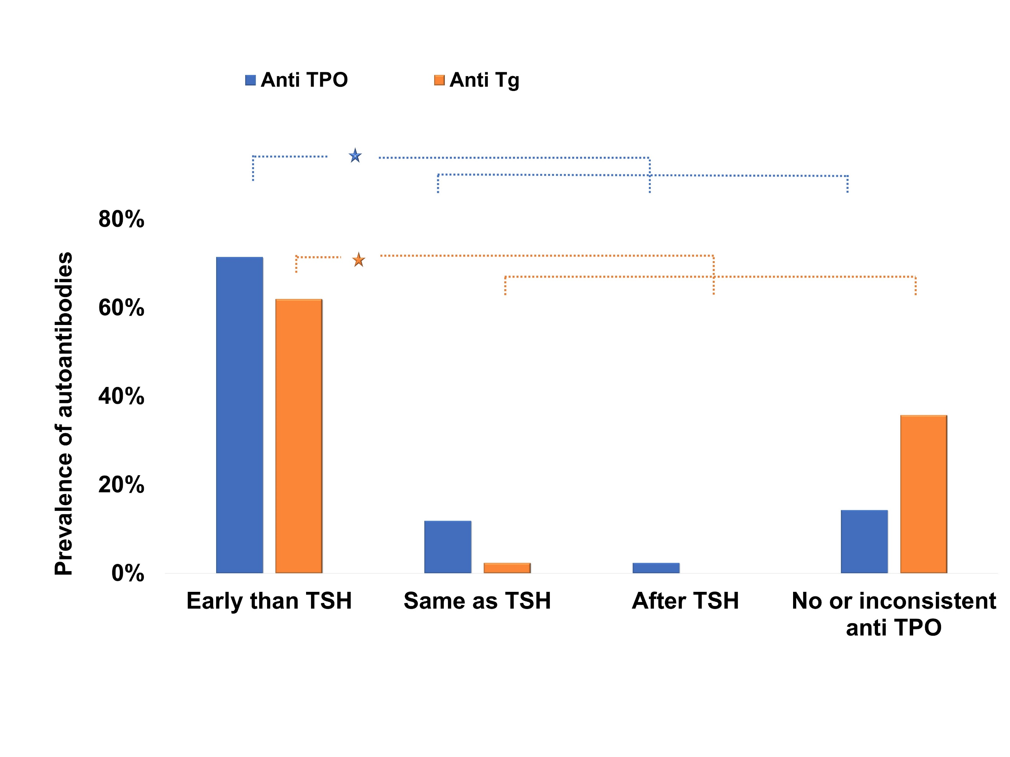
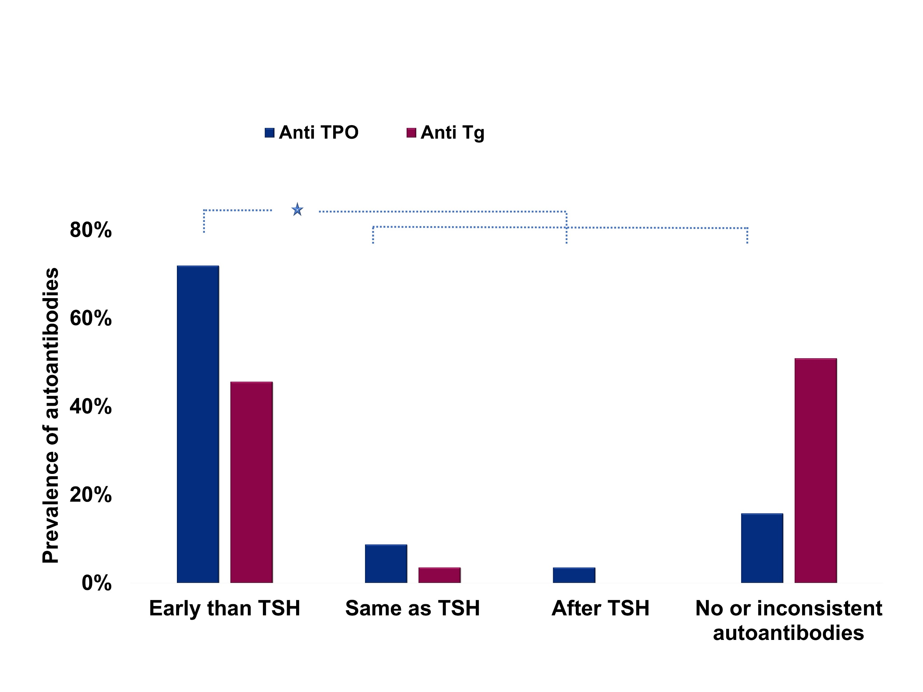
Group B1 (TSH and FT4 was in range for the first visit and subsequently converted to subclinical/ overt hypothyroidism) and group B2 (TSH and FT4 was in range for the first visit and subsequently converted to subclinical/ overt hyperthyroidism) were evaluated for the early occurrence of anti-TPO and anti-Tg autoantibodies. A total of 30 (71%) and 26 (62%) subjects of group B1 had anti-TPO and anti-Tg prior to any out-of-range TSH or FT4 level in an average time of 263(±31) days and 218(±94) days respectively. Similarly, 41 (72%) subjects of group B2 had anti-TPO prior to developing into out-of-range TSH and FT4 levels in an average of 292(±163) but the occurrence of anti-Tg was
A
B

Figure 4. Prevalence of anti-TPO and anti-Tg in group B1(A) and group B2(B) with subjects who were converted to subclinical/overt hypothyroidism

not significant. These results prove that they are useful not only as early predictive markers but also as secondary confirmatory markers in borderline TSH subjects with sub clinical hypothyroidism/ hyperthyroid disease. Moreover, the results were consistent with Huftless et al where they confirmed that anti-TPO was present in 66% Hashimotos patients and 57% Grave’s diseases patients before 7 years of clinical diagnosis.⁸ They also showed that anti-Tg was not as prominent as anti-TPO with a low percentage of 57% in Hashimoto’s patients and 47% in Graves’ disease patients in their study.⁸ Similarly, our data showed anti-Tg had seen early in only 61% of subclinical/overt hypothyroid patients but showed a non-significant difference of 45% in patients who developed into sub-clinical/overt hyperthyroidism.
Finally, we evaluated each antibody’s ability to perform as a standalone test in group B1 and B2. These subjects were compared, first with the subjects that were only assessed for early incidence of anti TPO and then with the subjects that were only assessed for early incidence of anti Tg separately in both sub clinical/overt hypothyroidism and hyperthyroidism. Of the 42 subjects in group B1 who
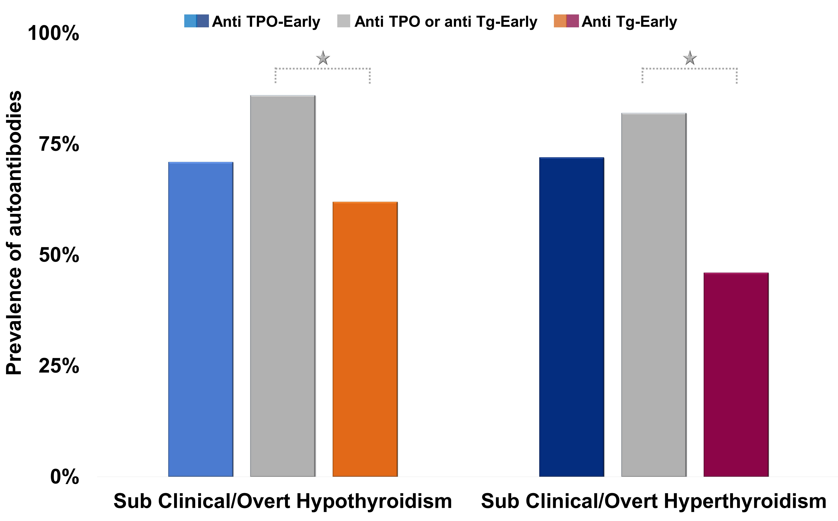
had converted to sub clinical/overt hypothyroidism, 36 (85%) had either anti TPO or anti Tg early than the onset of sub clinical/overt hypothyroidism compared to 30 subjects who had early incidence of anti-TPO and 26 subjects who had early incidence of anti Tg alone. Within the 57 subjects who converted to sub
Figure 6. Comparison of the prevalence of anti TPO, anti Tg and combined anti TPO or anti Tg in subjects converted to sub clinical/overt hypothyroidism (group B1) and hyperthyroidism (group B2).
clinical/overt hyperthyroidism in group B2, 47 (82%) had either anti TPO or anti Tg, 41 (72%) had anti TPO and 26 (46%) had anti Tg early. Between the subjects who converted to sub clinical/overt hypothyroidism and hyperthyroidism, there were no significant difference in subjects who were assessed for anti TPO alone compared to anti TPO or anti Tg together. But when assessed for anti Tg, for the subjects who converted to sub clinical/overt hypothyroidism (p=0.01314) and hyperthyroidism (p=0.0001) showed a significant difference compared to the combined anti TPO or anti Tg assessment. Hence, it clearly proved that there was no significant effect from anti Tg to the anti TPO performance, thus can be used as a standalone marker. But when the positivity of anti Tg was assessed alone and compared to the combined anti TPO or anti Tg assessment, the combined group of anti TPO or anti Tg showed significantly higher results than anti Tg alone.
CONCLUSION
our results showed that thyroid autoantibodies have a strong early appearance in subjects who developed into sub-clinical/overt hypothyroidism and hyperthyroidism that has the likelihood of eventually developing in to clinical thyroid disease. Hence, it would be beneficial to use anti-TPO and anti-Tg as first line screening markers in conjunction with the primary thyroid markers, TSH and FT4 to plan frequent follow up testing to reduce long term morbidity and mortality.
REFERENCES
1. Ladenson, P. W.; Singer, P. A.; Ain, K. B.; Bagchi, N.; Bigos, S. T.; Levy, E. G.; Smith, S. A.; Daniels, G. H.; Cohen, H. D., American Thyroid Association guidelines for detection of thyroid dysfunction. Arch Intern Med 2000, 160 (11), 1573-5.
2. Medici, M.; Korevaar, T. I.; Schalekamp-Timmermans, S.; Gaillard, R.; de Rijke, Y. B.; Visser, W. E.; Visser, W.; de Muinck Keizer-Schrama, S. M.; Hofman, A.; Hooijkaas, H.; Bongers-Schokking, J. J.; Tiemeier, H.; Jaddoe, V. W.; Visser, T. J.; Peeters, R. P.; Steegers, E. A., Maternal early-pregnancy thyroid function is associated with subsequent hypertensive disorders of pregnancy: the generation R study. J Clin Endocrinol Metab 2014, 99 (12), E2591-8.
3. Triggiani, V.; Iacoviello, M., Thyroid disorders in chronic heart failure: from prognostic set-up to therapeutic management. Endocr Metab Immune Disord Drug Targets 2013, 13 (1), 22-37.
4. Hampton, J., Thyroid gland disorder emergencies: thyroid storm and myxedema coma. AACN Adv Crit Care 2013, 24 (3), 325-32.
5. Stockigt, J., Assessment of thyroid function: towards an integrated laboratory--clinical approach. Clin Biochem Rev 2003, 24 (4), 109-22.
6. LeFevre, M. L.; Force, U. S. P. S. T., Screening for thyroid dysfunction: U.S. Preventive Services Task Force recommendation statement. Ann Intern Med 2015, 162 (9), 641-50.
7. Siemens Medical Solutions USA, I.
8. Hutfless, S.; Matos, P.; Talor, M. V.; Caturegli, P.; Rose, N. R., Significance of Prediagnostic Thyroid Antibodies in Women with Autoimmune Thyroid Disease. J Clin Endocrinol Metab 2011, 96 (9), E1466–E1471.

